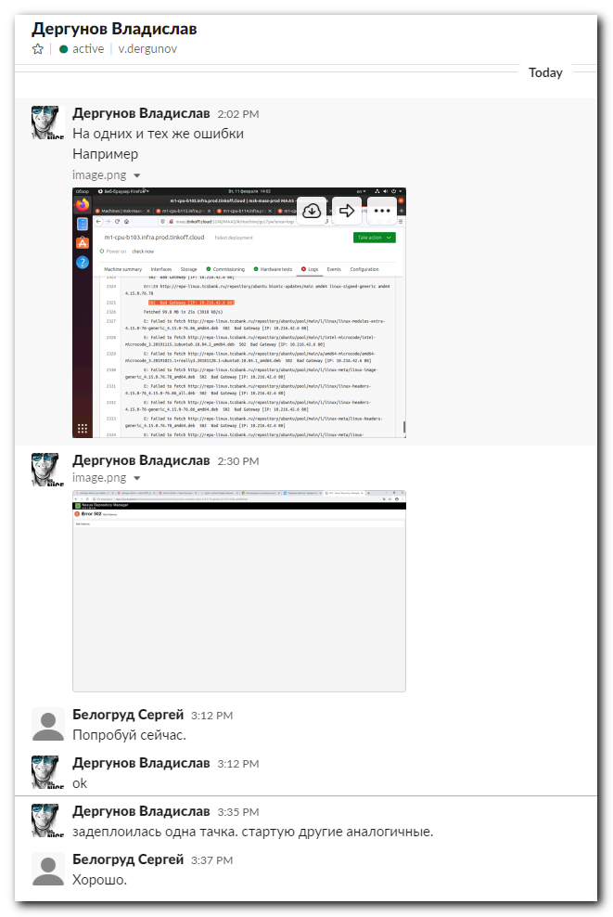
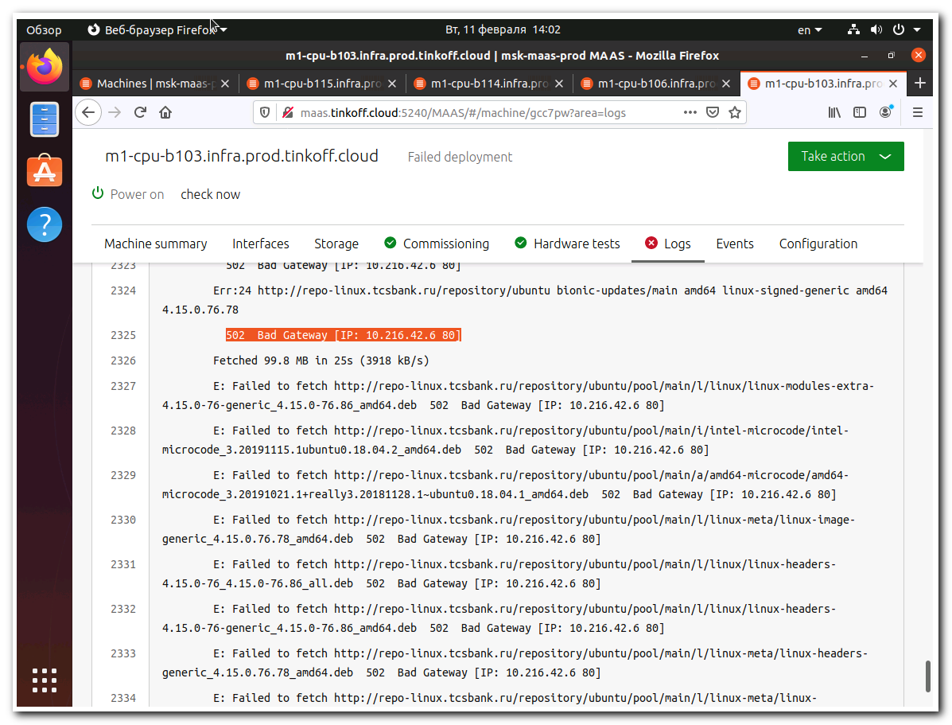

#
# Let’s test download the first URL. The URL is available via Nexus.
#
[root@ds-repo01 ~]# wget http://repo-linux.tcsbank.ru/repository/ubuntu/pool/main/l/linux/linux-modules-extra-4.15.0-76-generic_4.15.0-76.86_amd64.deb
--2020-02-11 15:05:42-- http://repo-linux.tcsbank.ru/repository/ubuntu/pool/main/l/linux/linux-modules-extra-4.15.0-76-generic_4.15.0-76.86_amd64.deb
Resolving mwg.gtm.tcsbank.ru... 10.218.11.50
Connecting to mwg.gtm.tcsbank.ru|10.218.11.50|:8080... connected.
Proxy request sent, awaiting response... 502 Bad Gateway
2020-02-11 15:06:12 ERROR 502: Bad Gateway.

[root@ds-repo01 ~]#

#
# Let’s test direct link to same package.
# Try to download it paypass Nexus. Just directly via proxy.
# It’s work. I’ve noted, that this download takes about 30 seconds. Not very fast. Because the package has size.
#
[root@ds-repo01 ~]# http_proxy=proxy.tcsbank.ru:8080 time wget http://us.archive.ubuntu.com/ubuntu/pool/main/l/linux/linux-modules-extra-4.15.0-76-generic_4.15.0-76.86_amd64.deb
--2020-02-11 15:07:55-- http://us.archive.ubuntu.com/ubuntu/pool/main/l/linux/linux-modules-extra-4.15.0-76-generic_4.15.0-76.86_amd64.deb
Resolving mwg.gtm.tcsbank.ru... 10.218.6.49
Connecting to mwg.gtm.tcsbank.ru|10.218.6.49|:8080... connected.
Proxy request sent, awaiting response... 200 OK
Length: 32726552 (31M) [application/x-debian-package]
Saving to: “linux-modules-extra-4.15.0-76-generic_4.15.0-76.86_amd64.deb”

100%[======================================================================================================================================================================>] 32,726,552 1.02M/s in 31s

2020-02-11 15:08:26 (1.01 MB/s) - “linux-modules-extra-4.15.0-76-generic_4.15.0-76.86_amd64.deb” saved [32726552/32726552]

0.14user 0.60system 0:31.26elapsed 2%CPU (0avgtext+0avgdata 7472maxresident)k
232inputs+63920outputs (2major+528minor)pagefaults 0swaps
[root@ds-repo01 ~]#

[root@ds-repo01 ~]# file linux-modules-extra-4.15.0-76-generic_4.15.0-76.86_amd64.deb
linux-modules-extra-4.15.0-76-generic_4.15.0-76.86_amd64.deb: Debian binary package (format 2.0)
[root@ds-repo01 ~]#

[root@ds-repo01 ~]# mv linux-modules-extra-4.15.0-76-generic_4.15.0-76.86_amd64.deb /tmp/

#
# Here I’ve increced connection timeout for this repository.
# It allow to wait, when proxy.tcsbank.ru complete download the package and return it to Nexus.
#
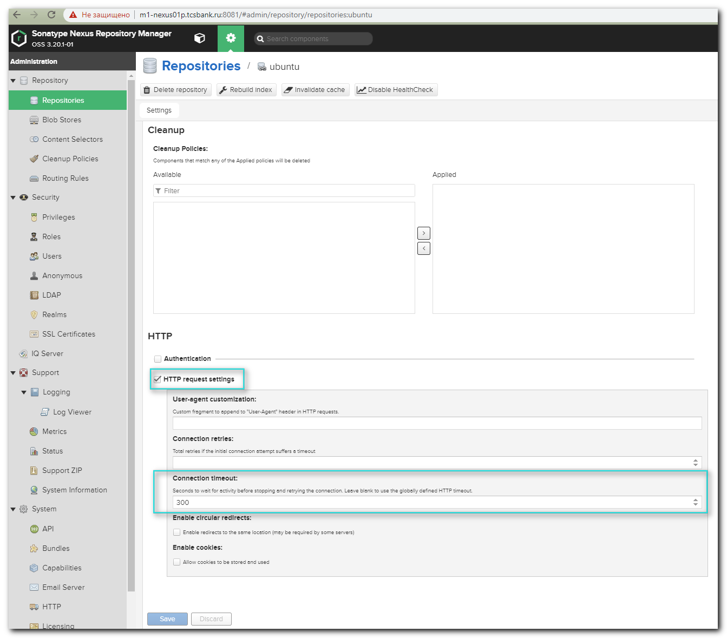

#
# After timeout was increased the package start download corrctly.
#

#
# And after the package was downloaded correctly fist time and after it was cached by Nexus.
# Download speed significantly increased and time to download became very short.
#
[root@ds-repo01 ~]# time wget http://repo-linux.tcsbank.ru/repository/ubuntu/pool/main/l/linux/linux-modules-extra-4.15.0-76-generic_4.15.0-76.86_amd64.deb
--2020-02-11 15:12:55-- http://repo-linux.tcsbank.ru/repository/ubuntu/pool/main/l/linux/linux-modules-extra-4.15.0-76-generic_4.15.0-76.86_amd64.deb
Resolving mwg.gtm.tcsbank.ru... 10.218.11.51
Connecting to mwg.gtm.tcsbank.ru|10.218.11.51|:8080... connected.
Proxy request sent, awaiting response... 200 OK
Length: 32726552 (31M) [application/x-debian-package]
Saving to: “linux-modules-extra-4.15.0-76-generic_4.15.0-76.86_amd64.deb”

100%[======================================================================================================================================================================>] 32,726,552 42.8M/s in 0.7s

2020-02-11 15:12:55 (42.8 MB/s) - “linux-modules-extra-4.15.0-76-generic_4.15.0-76.86_amd64.deb” saved [32726552/32726552]

real 0m0.792s
user 0m0.007s
sys 0m0.121s
[root@ds-repo01 ~]#

[root@ds-repo01 ~]# file linux-modules-extra-4.15.0-76-generic_4.15.0-76.86_amd64.deb
linux-modules-extra-4.15.0-76-generic_4.15.0-76.86_amd64.deb: Debian binary package (format 2.0)
[root@ds-repo01 ~]#
[root@ds-repo01 ~]# rm linux-modules-extra-4.15.0-76-generic_4.15.0-76.86_amd64.deb
rm: remove regular file `linux-modules-extra-4.15.0-76-generic_4.15.0-76.86_amd64.deb'? y
[root@ds-repo01 ~]#



